Data Representation

Lab 05.1: CURL

Lecturer: Andrew Beatty

* In this lab we will make some CURL commands on the command line

1. Test to see if CURL is working from you command line.

curl google.com

You should get a 301 error saying that the page has moved

**Result :**

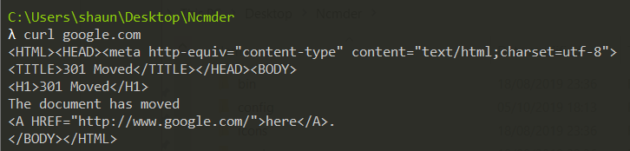

1. You can check this by using the –i option

curl -i google.com

**Result :**

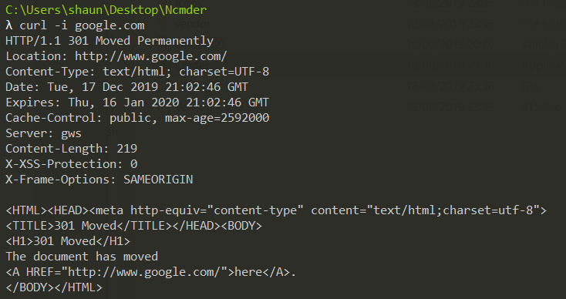

1. Look at the website <http://dummy.restapiexample.com/>
   1. What the curl command be to view all the employees?
   2. What would the curl command be to view employee 2202?

curl <http://dummy.restapiexample.com/api/v1/employees>

curl http://dummy.restapiexample.com/api/v1/employee/2202

**A Result –**

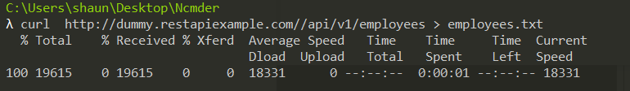

Employees.txt file output also attached

**B Result –**

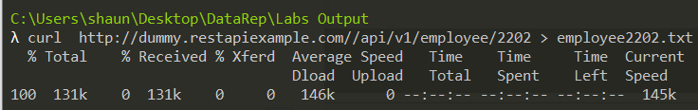

Employee2202.txt file output also attached

1. For the same web site how would you use curl to delete an employee

curl -X DELETE http://dummy.restapiexample.com/api/v1/delete/1000

**Result –**

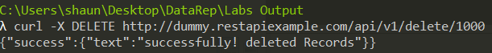

1. For the same website how would you use curl to create an employee, you may need to make the employee name unique
   1. Windows (windows only has “ (no ‘) so the data needs to be between “ “ and all the inverted commas in the JSON need to be escaped \”. (This is a pain)

curl -i -d “{\"name\":\"jj\",\"salary\":\"123\",\"age\":\"23\"}” -H “Content-Type: application/json” -X POST http://dummy.restapiexample.com/api/v1/create

**Result –**



createEmployee2.txt file attached for output

1. For the same website how would you use curl to update an employee

curl -d “{\"name\":\"Mary\",\"salary\":\"12000\",\"age\":99}” -H “Content-Type: application/json” -X PUT http://dummy.restapiexam

ple.com/api/v1/update/2202

* 1. Windows

Result -



updateEmployee.txt file attached with output